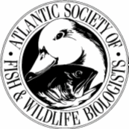

ATLANTIC SOCIETY OF FISH AND WILDLIFE BIOLOGISTS
AGM Information

The 46th Annual Meeting
Kouchibouguac National Park, New Brunswick
http://www.pc.gc.ca/eng/pn-np/nb/kouchibouguac/visit/visit2.aspx
October 20-22, 2009

Abstracts for Papers/Posters due by September 28th;
please send abstracts to Eric Tremblay at Eric.Tremblay@pc.gc.ca

Accommodations:

To receive these rates at Kouchibouguac Resort reservations must be made by October 15th

Kouchibouguac Resort (next to Kouchibouguac Nat. Park at the junction of trail head and Route 134) (http://www.kouch.com/)
Chalets: 1 queen bed upstairs and 1 double futon downstairs
$115.00 per night for the chalet for non-students
$95.00 per night for the chalet for students
- The Chalets sleep up to four.

Rooms: $65.00 for a room with 1 double bed (non-students)
$75.00 for a room with two double beds (students)

Alternatives for accommodations if the Kouchibouguac Resort is full are the following.
- Silver Birch Motel (Richibucto-15k from park), 1-800-361-2488, http://silverbirchmotel.com/
- Chalets du Havre (Richibucto-12k from park), 1-800-277-9037, http://www.chaletduhavre.nb.ca/

How to get here:

 | From Moncton:  Take Highway 15 to Shediac. Turn north on Highway 11 towards Miramichi. Take Exit 75 for the Kouchibouguac National Park. We are located just to the right of the park entrance, on Route 134 (400 meters)  From Miramichi:  Take Highway 11 towards Moncton, take Exit 75 for the Kouchibouguac National Park. We are located just to the right of the park entrance.  Navigation System;  Our cordinates are  46 deg 45 min 54 sec, N  65 deg 00 min 49 sec W
  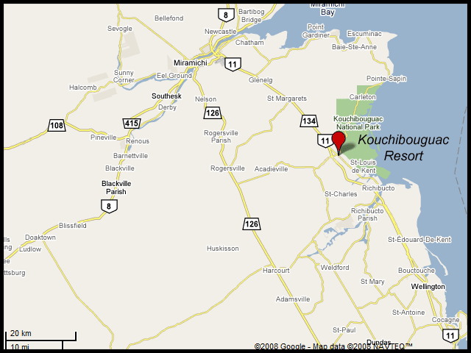

Oral Presentations:

A schedule will be posted once finalized. Presentations will be 15 minutes in length, with 5 minutes extra for questions. Please put your Microsoft PowerPoint presentation on a compact disk or USB memory stick and give it to one of the meeting organizers before 9am or 1:00pm the day of your presentation (depending on the session in which you present). Presenters using slides or overheads need to inform us well in advance.
Poster Presentations:
Posters and displays will be displayed at the meeting. Please bring items to hang or mount your poster if possible.

An award of $100 is given to the best student presentation.

Registration:

The registration cost will be $40 for non-students, and $20 for students. Registration will occur at the icebreaker on Tuesday night (October 20th) at the Kouchibouguac Resort from 7-10 pm. Participants may also register during the meeting but are encouraged to attend the icebreaker.

The registration fee includes nutrition breaks, refreshments and lunch on Wednesday and Thursday (soup and sandwiches).

Banquet:

The annual banquet will be held on Wednesday night (October 21st) from 7-10 pm at the Kouchibouguac Resort

The banquet cost is $30 for non-students and $20 for students. You must purchase tickets during registration. A cash bar will be available.

Silent Auction

Our annual silent auction will also be held during the banquet in order to raise funds to support the Scholarship Program. Please bring to the banquet any items you believe people would like to bid on. This event is a lot of fun and we usually raise a considerable amount each year.

Field Trip

There will be a guided walk at Kelly’s Beach coastal area at 7 am on Wednesday October 21.

