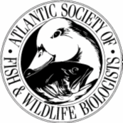

ATLANTIC SOCIETY OF FISH AND WILDLIFE BIOLOGISTS
CALL FOR PAPERS

The 46th annual meeting of the Atlantic Society of Fish and Wildlife Biologists will be held October 20th-22nd, 2009 at Kouchibouguac National Park, New Brunswick

The membership represents a wide variety of working biologists and a broad range of topics is the norm. These include, but are not limited to, research, monitoring, and management of species and habitats, wildlife harvest, applications of old and new techniques, people management, conservation planning, stewardship programs and partnerships, watershed approaches to habitat conservation, endangered species programming and educational efforts.

Abstracts for Papers/Posters due September 28th;
please send to eric.tremblay@pc.gc.ca

The student delivering the best paper is awarded $100.00.

Conference Organizer:
Eric Tremblay
Park Ecologist
Kouchibouguac National Park
186 route 117
Kouchibouguac National Park Tel: 506-876-2443
New Brunswick, E4X 2P1 Fax: 506-876-4802

