Wall Climbing for Acrophobiacs
by Jerome Bruhm

It’s January. It’s winter. It’s cold. We’re all climbing the walls, waiting for spring to arrive. What better time to go wall climbing?



This was a trial run for Gonzos. Ground Zero is located in the Burnside Industrial Park. Mark Bernard, an experienced climber (and one of my top buddies), offered to babysit us for the evening of Saturday, January 17th. A number of us responded to the challenge.

The Gonzo section of our gang consisted of Barb Hall, Greg Vail, Bruce Murphy, Bruce Duffy, Chris Hollebone and yours truly. Betty Hollebone came along to watch, to laugh at us and to photograph the event.

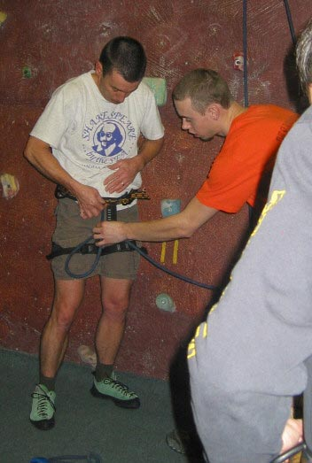
All you need is loose-fitting clothes, shoes & a harness (available at the gym) and the understanding that you’ll look stupid as you gangle your way up the wall for the first few times. Being an acrophobiac is not a plus. I’m a docile acrophobiac.

Not so fast now. You have to go through a 10 minute instruction session before you mount the walls – how to put the harness on; how to tie in; how to go up the wall and (most important of all) how to get back down. There’s also the odd little extra thrill (as Murphy will testify) when someone checks too see that your harness is properly strapped on.

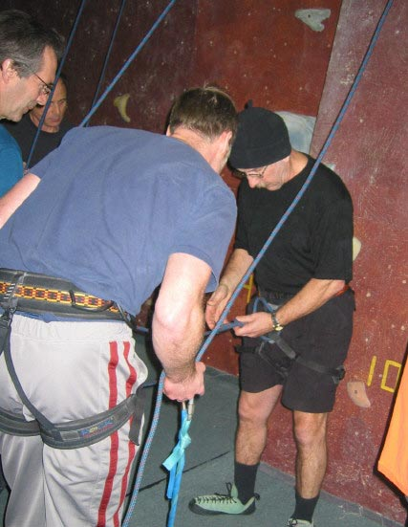
Now we’re ready to go.

- Shoes on.

- Harness on and checked. Straps double looped back through the buckles.

- Tied in, using the double figure-8 knot

- Toque properly pulled down over your ears

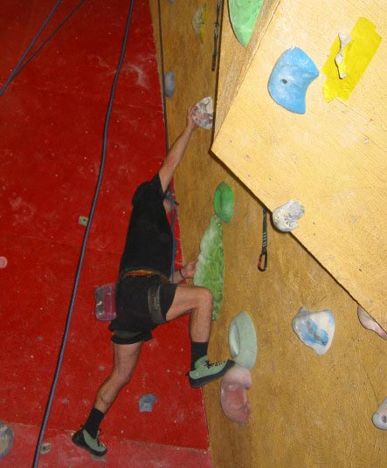
- Up you go!!!!!

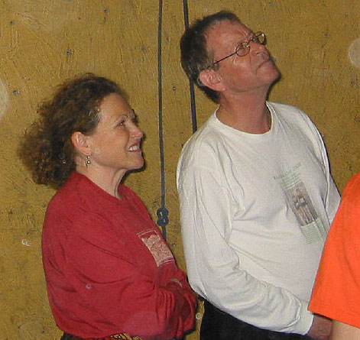

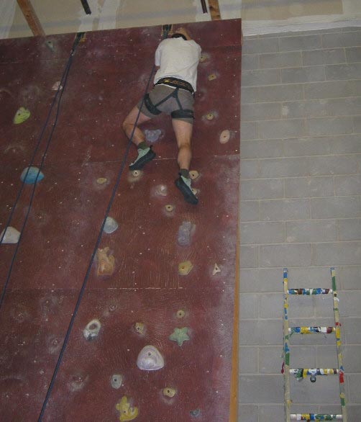

There are 11 separate climbing walls at Ground Zero, each 24 feet high and of varying degrees of difficulty. Some tilt in, some are flat, some tilt out. The object, of course, is to get to the top.

Afraid of falling? Not a problem.You are tied in, and you have a person (a belayer) at the bottom who is keeping a strain on your rope. If you happen to slip, you just dangle from that spot until you regain your grip on the wall.

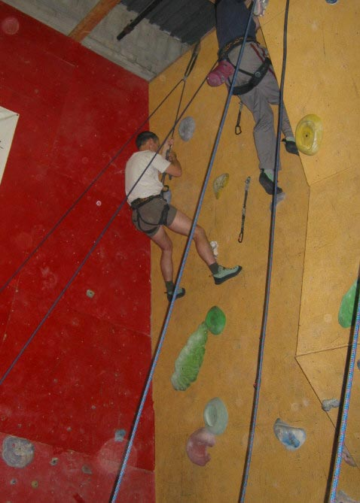
See, nothing to it.

Just climb up the wall. When you’re ready to come down, you simply take a deep breath, let go of the wall and sit back in your harness. (It’s a hard move the first few times.) Your belayer will lower you back to the floor.

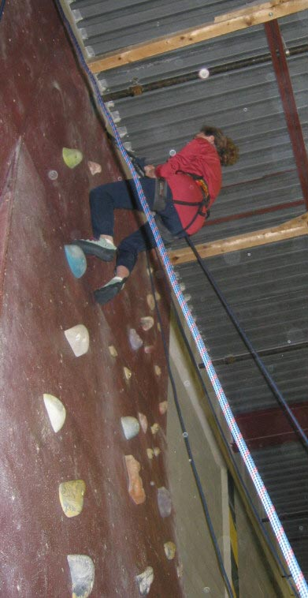

The climbing rope (known as a top rope) is strung through a clip at the top of the wall. One end of the rope is attached to your harness; the other end goes through a locking belay device, which is anchored to the floor.

As you climb, your belayer will pull the slack rope through the belay device, thus keeping a strain on it. If you slip off the wall you don’t drop because the belay device will lock up (like a seat belt in a car) and, since it’s anchored to the floor, you just dangle at the height from which you are sure you were going to fall and break your neck. Simply grab the nearest hand & foot holds and you’re back on the wall again.

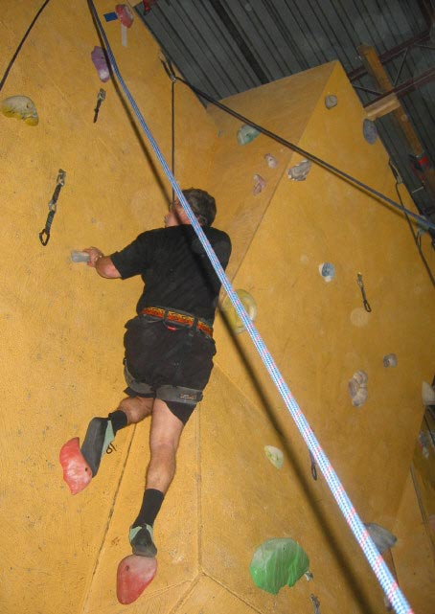
You start off on an easy wall and, when you are ready for it, you progress to a more challenging wall, which will have fewer hand and foot holds and may be tilted outward or have an overhang for you to navigate.

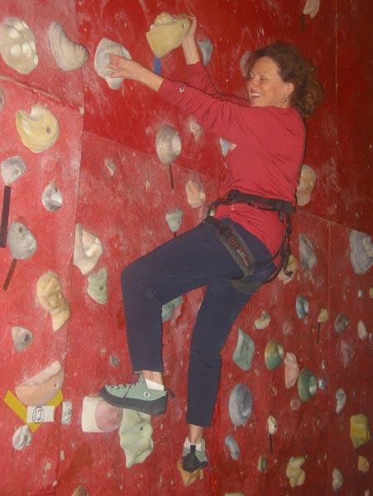

Or, you can try a bouldering route. There’s 30 separate routes, graded 1 through 30 (easiest to hardest). No top rope attached as you are just inches above floor level, and there’s a big fluffy pad awaiting your impending demise.

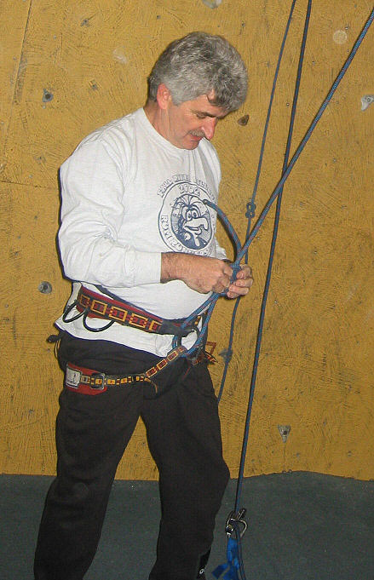
A small group of us have been going to Ground Zero on Tuesday nights (6:00 – 8:30). So far we’ve enticed additional Gonzos Wayne Banks, Ian Blair and Mark Stein to join in. And Murphy has been back too. Wanna’ give it a try?

I find it to be a great way to work on upper body strength, overall flexibility and (ahem) weight control, as is clearly evident in the photo to the left which was taken 8 weeks, and 14 pounds, ago.

As for my fear of heights, it’s still there, but I’m learning to deal with it rather well. Another bonus.

And, by the way, the main difference between a serious climber and, well, an idiot is that the serious climber doesn’t giggle when an attractive lady climber asks him if he’d like to “belay” her.

