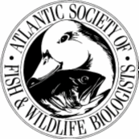

ATLANTIC SOCIETY OF FISH AND WILDLIFE BIOLOGISTS
AGM Information

The 47th Annual Meeting
Humber Valley Resort, Newfoundland
www.humbervalley.ca
October 5-7, 2010

Abstracts for Papers/Posters due by September 25th;
please send abstracts to Casidhe Dyke at Casidhedyke@gov.nl.ca

Accommodations:

Humber Valley Resort (Located at the southern end of Deer Lake) (www.humbervalley.ca)
Accommodations are chalet style, with typically 5 rooms per chalet. If you are part of a group who would like to be accommodated within the same chalet please mention this at the time of booking. Otherwise, room and chalet assignments will be designated by the coordinators.

- Cost per room is anticipated to be a maximum of $100/night
- Final cost and booking details will be forwarded shortly
- To receive special rates for attendees please refrain from booking until further details have been supplied.

Alternatives for accommodations to the Humber Valley Resort are the following.
- Marble Inn Resort (Steady Brook – 13 km from the Resort), 1-877-497-5673, www.marbleinn.com
- Georges Mountain Village (Steady Brook – 14 km from the Resort), (709) 639-8168, www.georgesskiworld.com
- MarbleWood Village (Steady Brook – 14 km from the Resort), 1-888-868-7635, www.marblemountain.com
- The Greenwood Inn and Suites (Corner Brook – 23 km from the Resort), 1-800-399-5381, www.greenwoodcornerbrook.com

How to get here:

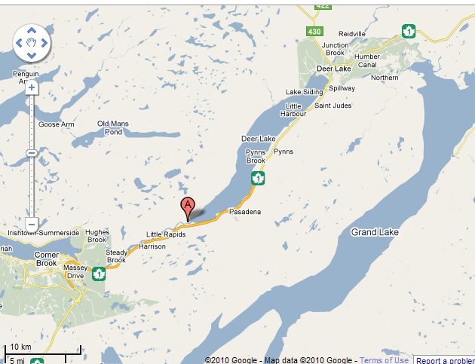 | From Deer Lake Airport: Head west on the Trans Canada Highway towards Corner Brook. Take Exit 11 for Little Rapids (Humber Valley Resort). Turn right, then turn left across the bridge. Total distance 35.8 km.  From Port aux Basques: Head east on the Trans Canada Highway towards Deer Lake. After Corner Brook, take exit 11 for Little Rapids (Humber Valley Resort). Turn left under the highway, then right, and then left across the bridge. Total distance 239 km.  Security Gate: Attendees are asked to inform security that they are participating in the conference upon their arrival.

Deer Lake Airport Transport: For those individuals requiring transportation from Deer Lake Airport to the Resort please contact Casidhe Dyke to make arrangements.

Oral Presentations:

A schedule will be posted once finalized. Presentations will be 15 minutes in length, with 5 minutes extra for questions. Please put your Microsoft PowerPoint presentation on a compact disk or USB memory stick and give it to one of the meeting organizers before 9am or 1:00pm the day of your presentation (depending on the session in which you present). Presenters using slides or overheads need to inform us well in advance.

Poster Presentations:
Posters and displays will be displayed at the meeting. Please bring items to hang or mount your poster if possible.

An award of $100 is given to the best student presentation.

Registration:

The registration cost will be $50 for non-students, and $30 for students. Registration will occur at the Meet and Greet on Tuesday night (October 5th) at the Humber Valley Resort from 7-10 pm. Participants may also register during the meeting but are encouraged to attend the Meet and Greet.
- The registration fee includes nutrition breaks, refreshments and lunch on Wednesday and Thursday.

Banquet:

The annual banquet will be held on Wednesday night (October 6th) from 7-10 pm at the Humber Valley Resort

The banquet cost is $40. You must purchase tickets during registration. A cash bar will be available.

Silent Auction

Our annual silent auction will also be held during the banquet in order to raise funds to support the Scholarship Program. Please bring to the banquet any items you believe people would like to bid on. This event is a lot of fun and we usually raise a considerable amount each year.

Field Trip

Options may exist for organised activities the afternoon/evening of October 7th. Possible activities include:
- Hiking
- Trap shooting
- Zip lining
- Caving
- Golfing
Please contact the coordinators for more information either before or during the conference.

