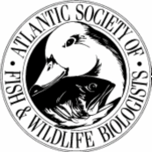

ATLANTIC SOCIETY OF FISH AND WILDLIFE BIOLOGISTS
CALL FOR PAPERS

The 42nd annual meeting of the Atlantic Society of Fish and Wildlife Biologists will be held October 5th-7th, 2004 at the Hugh John Flemming Forestry Complex, Fredericton, New Brunswick..

Abstracts for Papers/Posters due September 20;
please send to forbes@unb.ca

The student delivering the best paper is awarded $100.00.

Conference Organizers:
Graham Forbes
NB Cooperative Fish and Wildlife Research Unit, University of New Brunswick, E3B 6C2, Fredericton, NB. (forbes@unb.ca), 506-455-5923(work phone), 506-453-3538 (fax)

Kevin Connor
Fish and Wildlife Branch, NB Dept. Natural Resources and Energy, Fredericton, NB
(K.Connor@gnb.ca

