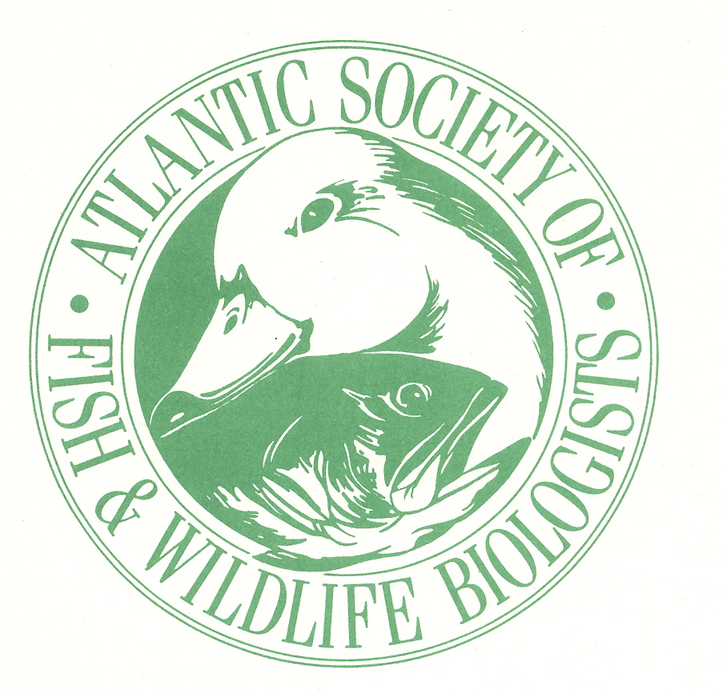Atlantic Society of Fish & Wildlife Biologists
Annual Spring Seminar – 21 April 2016

Crabtree Auditorium Mt. Allison, University, Sackville, NB

Environmental Assessment

0900 Registration opens

1000 Welcome and announcements

1010 John Kearney, John F. Kearney & Associates: Avian Assessments at Wind Energy Facilities: An Evaluation of Current Practice

1035 Scott Dickey, Strum Consulting: Environmental Assessment from the Consulting Perspective

1100 Eric Tremblay, Parks Canada: Federal Major Infrastructure Investments and Conservation Gains: Are They Compatible? The Case of Highway 117 in Kouchibouguac National Park”

1125 David Mazzerolle, Atlantic Canada Conservation Data Centre: Atlantic Conservation Data Centre Contributions to the Environmental Impact Assessment Process”

1150 Lunch (Executive Meeting)

1300 Announcements

1315 Helen Yeh, Nova Scotia Environment: Provincial EA Process in Nova Scotia

1340 Michael Hingston, Environment and Climate Change Canada: Federal Environmental Assessment Process

1405 Dave Maguire, New Brunswick Department of Environment and Local Government: Title TBD

1430 Rachel Gatreau, Canadian Wildlife Service: Environmental Assessment from the Perspective of the Canadian Wildlife Service

1500 Wrap Up and Departure

